**СЕРІК Ғазиза,**

**№131 жалпы орта білім беретін мектебінің 7 «Г» сынып оқушысы.**

**Жетекшісі: ДЖАЛИЛОВА Дильбар Умартаевна.**

**Шымкент қаласы**

**SIGHTSEEINGS OF GREAT BRITAIN**

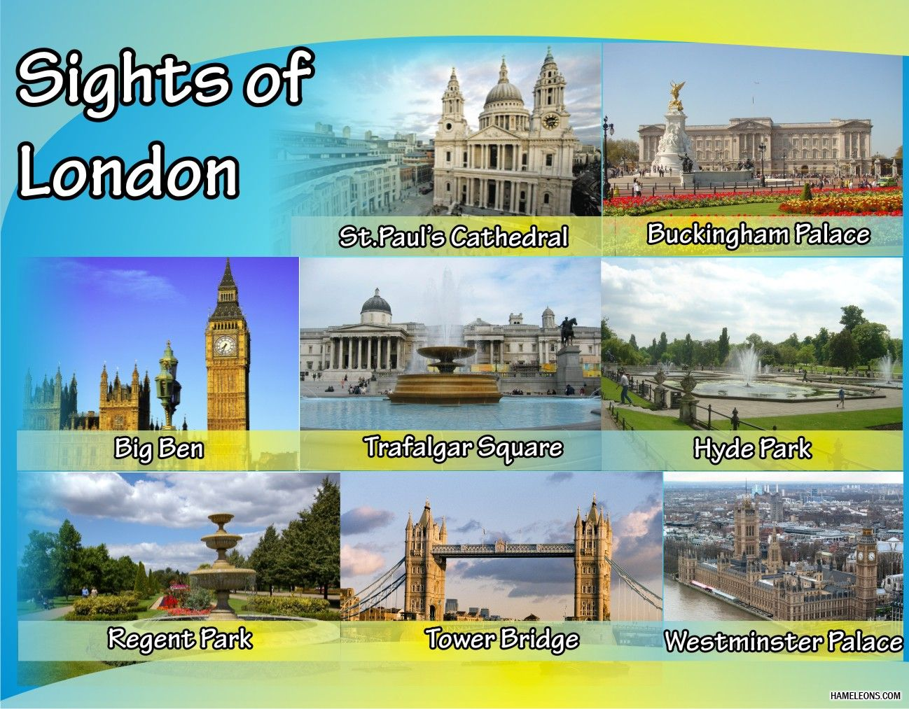

The capital of Great Britain is full of popular and world-famous tourist attractions, both educational and entertaining. Most of them are located close to the river Thames, others are in different parts of London and in its suburbs. The city was founded about 2 000 years ago, so there are a lot of interesting historic and architectural sights.

Big Ben is the most famous iconic clock tower of the Houses of Parliament. Behind this long and beautiful building stands medieval Westminster Abbey where many historic weddings, coronations and burials took place. The Tower of London has rich history as a royal palace, a fortress, a prison and a place of execution. Not far from the Tower guests can see the magnificent architecture of St Paul’s Cathedral, originally designed by Sir Christopher Wren. In the middle of Trafalgar Square tourists stop to admire a 52-metre Nelson’s column dedicated to Admiral Lord Nelson. Buckingham Palace has been the official residence of British monarchs since the reign of Queen Victoria.

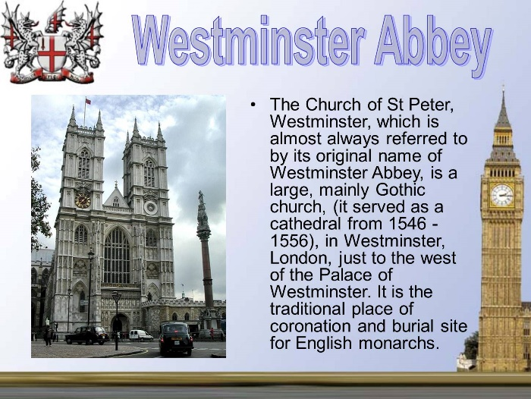

London is famous for its wonderful museums and art galleries. In British Museum one can see ancient paintings, sculptures and even Egyptian mummies. London’s National Gallery has the greatest collection of paintings of Van Gogh, Leonardo da Vinci, Renoir and many others. The Natural History Museum boasts its fabulous dinosaur exhibition. Tate Modern is a unique museum with the works of Picasso, Dali and other modern artists. The Science Museum is a technology thought-provoking museum with interactive galleries devoted to many fields of science: from space travel to psychology.

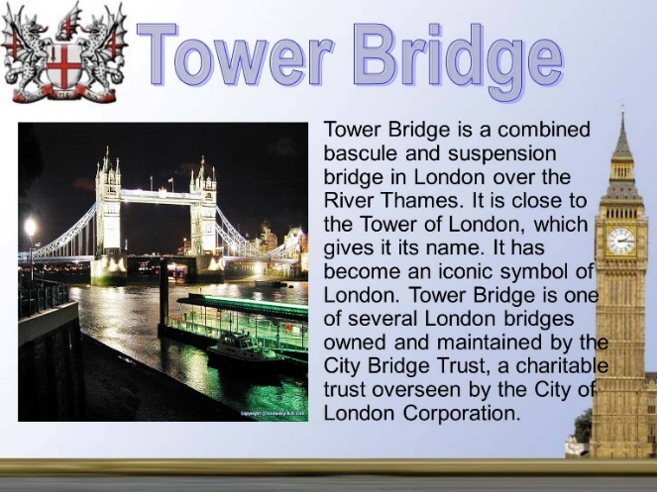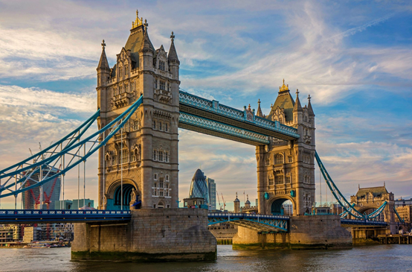

As for the entertaining, it is impossible to get bored in London. The best places for quiet relaxation are traditional English parks and gardens. The tourists’ favourites are Kew Gardens, Hyde Park, St. James’s Park, Green Park and Kensington Gardens. Right in the heart of the capital we can find London Zoo and London Aquarium. In Madame Tussauds Museum visitors will meet face to face with hundreds of celebrities: from Shakespeare to Lady Gaga because it’s an amazing collection of wax figures. Warner Bros. Studio Tour is an unbelievable behind-the-scenes tour where we can enjoy the magic of the Harry Potter films. The London Eye is a giant wheel that carries its visitors in one of its capsules for breathtaking experience above the city and its attractions.

